**PATH PLANNING FOR EFFECTIVE AND EFFICIENT SURFACE FINISH USING SHAPE ADAPTIVE GRINDING**

*Report submitted to*

*Indian Institute of Technology, Kharagpur*

*as M.Tech Thesis Project-I*

*Under the supervision of*

**Prof. Ajay M. Sidpara**

*by*

**Aayush Rajput**

**18ME31036**



**DEPARTMENT OF MECHANICAL ENGINEERING**

**INDIAN INSTITUTE OF TECHNOLOGY, KHARAGPUR**

**Nov 2022**

**CERTIFICATION**

This is to certify that this project report entitled “Path planning for effective and efficient surface finish using shape adaptive grinding” submitted to Department of Mechanical Engineering, Indian Institute of Technology, Kharagpur, is a bonafide record of work done by Aayush Rajput, roll no. 18ME31036, from the Department of Mechanical Engineering, Indian Institute of Technology, Kharagpur as his M.Tech thesis project-1 during the autumn semester, 2022-2023.

**Prof. Ajay M. Sidpara**

Assistant Professor

Department of Mechanical Engineering

Indian Institute of Technology, Kharagpur

**Date: 06.11.2022**

**Content Table**

1. **Introduction**
2. **Literature Review**
3. **Gaps in Literature and Objective**
4. **Material Removal Mechanism**
5. **Experimental Procedure**
6. **Result and Discussion**
7. **Conclusion**
8. **References**

**Introduction**

Manufacturing is the process of converting a raw material to a finished product using different types of tools. The manufacturing industry covers a large portion of the total industries of a nation. In India, the output from the manufacturing industry comprises 78% of the total industrial output. In the manufacturing of any product after the machining process, various finishing processes are performed on it. The finishing process allows companies to set a higher price for the final product as the finishing process improves many properties of a product. Some of the product improvements by finishing processes are corrosion reduction, surface defects removal, improved appearance, enhanced chemical resistance, and many more. These finishing processes account for 10-15% of the overall production cost of a product [1]. So there is a scope of studying the finishing processes and finding the best parameters for finishing to get the break-even sweet point where we can minimize the production cost without reducing the quality of a product.

Surface finishing is a process in which various techniques are used to reduce the roughness of a surface to achieve certain properties. Surface finishing techniques can be broadly classified into two groups, traditional surface finishing techniques, and advanced surface finishing techniques. Traditional surface finishing techniques include Honing, Grinding, and Lapping and advanced surface finishing techniques include Magnetorheological Finishing (MRF), Abrasive Flow Finishing (AFF), and Magnetorheological Abrasive Flow Finishing (MRAFF). Traditional surface finishing processes are used for a long time in industries and are simple and cheaper as compared to the advanced surface finishing processes. But the traditional surface finishing techniques have some limitations as they cannot be used when the shape of the part which has to be finished is complex or when the thickness of the part is less and a higher force can cause damage to the part. With technological advancements, many new advanced surface finishing processes are developed which can overcome the limitations of traditional surface finishing processes. In this study, we will study one of the advanced surface finishing techniques and the different parameters associated with it.

The problem with the other surface finishing techniques is that too much force on the surface starts the particles to pull out of the surface thus reducing the surface finish. Recently techniques that use flexible tools are used for processing material that is hard to finish. These processes use flexible tools so that it can be used on materials such as copper which are hard to finish. Shape adaptive grinding(SAG) is a type of advanced surface finishing technique which is used for finishing complex surfaces. It uses a flexible tool covered with nickel or resin-bonded diamond pellets. The elastic nature of the tools makes it possible to deform the tool according to the surface of the workpiece. Once the peaks which are increasing surface roughness are removed the surface area increases which will require a large force to be removed further, this will not allow the tool to remove particles from the plain surface thus surface finishing will not be degraded. A nanoscale surface finish can be achieved using this method on the materials like ceramics and hard metals which are difficult to machine. A surface finish below 0.5 nm Ra can be achieved by this method.

In any surface finishing process, a tool path is selected on which the tool moves over the surface which has to be finished. The tool path generation is the process of deciding the tool trajectory relative to the surface of the part. Different tool paths produce different types of surface finish based on the method used for surface finishing. The most commonly used tool paths are zig-zag, parallel, trochoidal, circular, etc. [2]. The type of material on which the finishing operation is done also influences the surface roughness produced using different tool paths.

**Literature Review**

Anwesa Barman et. al. [3] used Magnetic Field Assisted Finishing (MFAF) process to finish biomaterials at the nanometer level. Biomaterials are used in the medical industry for making implants. They finish the surface of a titanium workpiece using a specially designed tool. Two paths are used for the finishing process and various parameters for both surfaces were compared. The first path planning used was a parallel path and the second was the spiral path. The study showed that the parallel path generated a lower surface roughness (~10 nm) and a better surface texture. This study further analyzed the output over a range of input parameters like tool rotational speed, working gap, and finishing time, and found the optimal value of these parameters. The best value of change in surface roughness achieved using the parallel toolpath is 93.3% while using the spiral toolpath is 71.4% which shows that the surface obtained using the parallel toolpath has lower roughness.

Further, the effect of the rotational speed of the tool on surface roughness for parallel toolpath is analyzed and it was found that with increasing rotational speed surface roughness is decreased till 1200rpm after that the surface roughness begins to increase. This is because due to higher speed than a particular point the CIP chain structure of the magnetorheological fluid begins to distort thus reducing the surface finish quality.

Then the effect of finishing time on surface roughness was analyzed, and it was found that initially surface finish is increased with the increase in finishing time reaching a maximum value further increase in finishing time would cause the degradation in surface finish. The same pattern was seen with the working gap. Initially, an increase in the working gap would improve the surface finish to a maximum value; the further increase will degrade the surface finish.

Atul Singh Rajput et. al. [4] used a magnetorheological fluid-assisted finishing (MFAF) process for finishing a test specimen made of duplex stainless steel using a trochoidal path and zig-zag path, and it was found that the trochoid path produces a better-finished surface than the surface produced by the zig-zag path. It was also found that the trochoidal path achieved a 96.8% reduction in surface roughness in 70 minutes while using the zig-zag path only a 45.36% reduction was achieved. Experiments were performed to detect the corrosions rate of the workpiece after the surface finishing process using zig-zag and trochoidal paths and the result showed that the corrosion rate during the zig-zag toolpath is 0.013 mm/year which was higher than the trochoidal path i.e. 0.0114 mm/year. A wear test was also performed for both of the paths and the result showed that for the unpolished surface wear rate is 6.36 x 10-5 mm3/min which was very high as compared to the polished surface. While comparing the wear rate of the polished surface using zig-zag and trochoidal it was seen that the trochoidal toolpath’s wear rate was lower than the zig-zag toolpath. Further, the effect of different parameters (stepover, curve radius, feed rate) on surface roughness was analyzed. Stepover is the overlap between two consecutive circles of the trochoidal toolpath. With the increase in the overlap finish quality increases but the finishing time also increases. For curve radius, the average surface roughness increases with it, as the uncovered region’s area increases with an increase in curve radius for the trochoidal path. With an increase in feed rate the average surface roughness increases as with a higher feed rate interaction time of the surface with the tool decreases which causes a worse surface finish. However, too low a feed rate will also degrade the surface finish as the tool will start scratching the already polished surface. Gourhari Ghosh et. al. [5] used chemical-assisted SAG for the nano-finishing of WC-Co coating. Chemical Mechanical Polishing is a widely used method in the semiconductor industry. In this process, the rotating surface is compressed against the rotating pad and chemical abrasives are injected over it. So there is the effect of chemical as well as a mechanical force on the surface and both contribute to the polishing of the surface. This was a multi-step finishing strategy in which first SAG was done then the chemically assisted SAG was performed for a better finish. The chemical treatment made a layer on the top of the surface which was softer than the surface which helped in the uniform material removal rate. Later the X-ray photoelectron spectroscopy showed that a passivation layer of tungsten trioxide was present on the surface and no fracture was found on the surface. In the first step, grinding was done using the single-layer electroplated diamond wheel which reduced the surface roughness to a micron level. The SAG tool had a PMMA wheel and an abrasive pad of zirconia-alumina was attached to it. The polishing was performed using pads of different grit sizes (125, 80, and 60 μm) sequentially. In the next step, chemical-assisted SAG was performed using Murakami’s reagent (a solution of K3[Fe(CN)6], KOH, and distilled water in a 1:1:10 proportion). This reagent was applied at the contact zone using a syringe. A nano hardness test was also done to check the effect of Murakami's reagent on the surface hardness of WC-Co coating. Small slices of the coating were kept in the Murakami reagent for 3, 6, and 9 minutes. Some sides were covered with teflon tape to avoid a reaction between the surface and the reagent. Then several measurements were taken at different locations and the average hardness was compared. The results from the experiments showed that the chemical-assisted SAG is efficient in the finishing operation due to the combined action of chemical etching and mechanical abrasion. The surface finally achieved using this method had a surface roughness of 53nm. It was also observed that the reagent has no effect on the properties of the coating.

**Gaps in literature and Objectives**

Looking at the literature review it can be seen that there are many kinds of research have been done in this field. Though some of the areas are not very well covered by the researchers. The aim of this research is to fill those gaps in the field of surface finishing. The following gaps are identified for the path planning of shape adaptive grinding:

1. There is limited work on tool path planning in shape adaptive grinding.
2. The overlapping of the tool path is not extensively explored for the finishing process with soft tools.
3. The theoretical modeling of the forces acting at the tool-workpiece interface during the different tool paths is rarely addressed in the literature.
4. The contact model for finishing with soft tools is limited in the literature.

By using a different type of paths for surface finishing the forces on a single abrasive is changed in orientation which has an effect on the total surface finish of the workpiece. The overlapping of the tool path will also have its contribution to the overall finish so a different percentage of overlapping is used for the tool path planning. Theoretical modeling of the forces acting at the tool-workpiece interface during the different tool paths can be done which will be compared with the actual experimental results. These all parameters are tuned to get the best finishing of the workpieces. The objective of this research is to study all the points in detail and their effect on the surface finishing of workpieces in shape adaptive finishing.

Based on the above-mentioned gaps in the literature, the objectives of the present work are identified and presented as follows:

1. Development of different tool path strategies for shape adaptive grinding.
2. Commuter numerical control (CNC) programming of the different tool paths for the finishing process.
3. Study the effect of overlapping on the quality of the finished surface in the finishing process with soft tools.
4. Theoretical modeling of the finishing forces in the different tool paths and validation with the experimental results.
5. Analysis of tool-workpiece contact at a macroscale in shape adaptive grinding.

**Material Removal Mechanism**

During traditional finishing there is physical contact between the tool and the workpiece and the tool so there is a direct force on the particles on the contact surface of the workpiece and tool. In the case of the nontraditional or modern surface finishing process, there is no direct force between the workpiece and the tool, rather a third medium is introduced between them which acts as the abrasive material and provides a force on the surface of the workpiece for the removal of the irregular surface in the form of chips. Continuous use of the same grinding wheel is not possible as during the finishing process the abrasive particles get damaged and also there is the creation of cracks in the grinding wheel which is filled with waste material that is removed from the workpiece. So there is dressing and truing done at regular intervals for the grinding wheel for the best performance. Dressing the wheel surface removes the blunt abrasives present of the surface which are unable to help in the grinding process. The use of hard materials for the surface finishing makes it harder to provide dressing and truing. The dressing of harder materials is very difficult and very time-consuming which is a major disadvantage of them. To tackle this problem, shape adaptive finishing is used in which the grinding wheel is covered with a double-sided tape that contains the diamond particles as abrasive which are responsible for the final removal of chips from the workpiece to make to uniform. The tape is flexible so it adapts according to the surface of the workpiece and therefore it causes less deformation as compared to traditional surface grinding. The result of using the shape adaptive process using the flexible tape is that productivity increases and there is no time wastage for dressing the grinding we just change the diamond abrasive tape. There are mainly two types of forces that are applied on a single particle on the workpiece surface Ft (tangential)and Fn (normal). By using the shape adaptive grinding, the force on each particle changes as the curvature of the surface changes so the force profile is not very uniform.

**Experimental Procedure**

There are various paths available for the surface finishing zigzag, parallel, spiral, trochoidal etc. In a zigzag path, the direction of finishing at each step changes for e.g. if we start finishing the surface from left to right then after one step the direction of finishing will be reversed i.e. it will be from right to left. In the case of a parallel tool path, the direction in each step will be the same as the previous step after reaching at end of a particular step the tool will be lifted up and moved to the same side from where it started. Fig 1 shows the schematic of parallel and zigzag paths. These two paths are very similar to each other and the results of using these two tool paths will be similar. In parallel and zigzag paths there is some percentage of overlap between the current and previous path, changing the overlapping will give different results of surface finish. In this study, the overlapping percentage is changed for the parallel path and then the results are compared and the possible reason behind the results is explained.

Another type of tool path very often used in the field of surface finishing is a circular path in which the tool path is revolved around a fixed center on the surface of the workpiece. In this study, there will a comparison between the results obtained spiral path and the parallel. Fig 2. shows the schematic of the circular path used in the experiment in shape adaptive finishing.

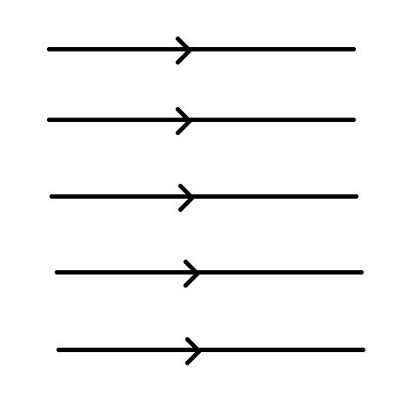 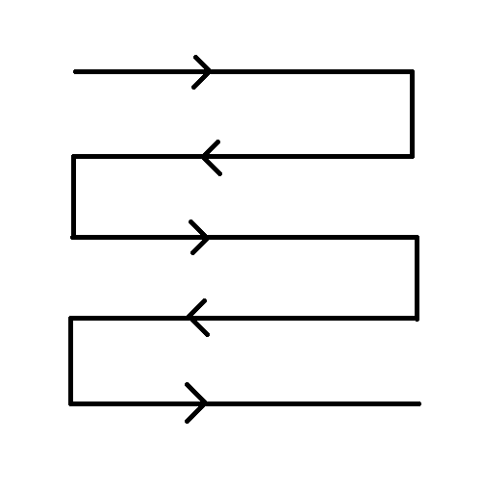

(a) (b)

Fig 1. (a) Parallel path and (b) zigzag path used in surface finishing

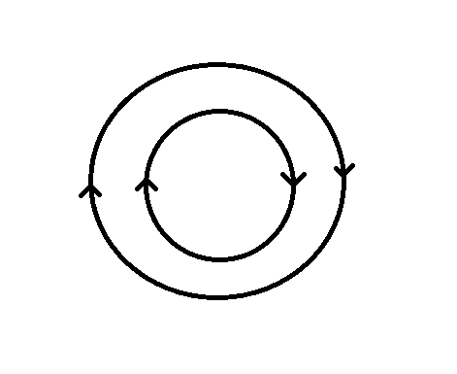

Fig 2. Circular path used in surface finishing

While doing surface finishing using shape adaptive grinding the compression of the tool into the surface should be kept low as we don’t want too much material removal from the workpiece and increasing the depth would also exert too much force on the tool which will eventually cause damage to the tool. A schematic of the shape of adaptive grinding is shown in Fig 4 in which the wheel is vertical and abrasive tape is attached to its circumference. In our experiment the tool is vertical and diamond abrasive tape is attached to top of the elastic material. A picture of the tool used in the experiment is given in Fig 5.

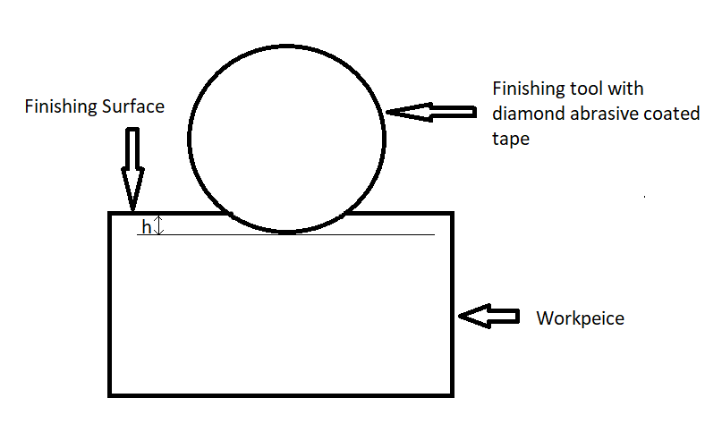

Fig 4. Shape Adaptive Grinding process mechanism

The layer above the abrasive tape used in the experiment has a flexible structure that can change its shape according to the geometry of the workpiece which has an advantage over using the rigid tool, the flexible tool gives a better finish than the rigid tool [6]. The flexible tool adjusts its shape to remove the irregularities present on the surface while the rigid tool sometimes removes the material from the already finished layer which sometimes increases the roughness of the surface. Using rigid tools for a higher time on the same surface will deteriorate the quality of the surface after a threshold time, which is not the case with the flexible tool because it adjusts its shape with respect to the surface.

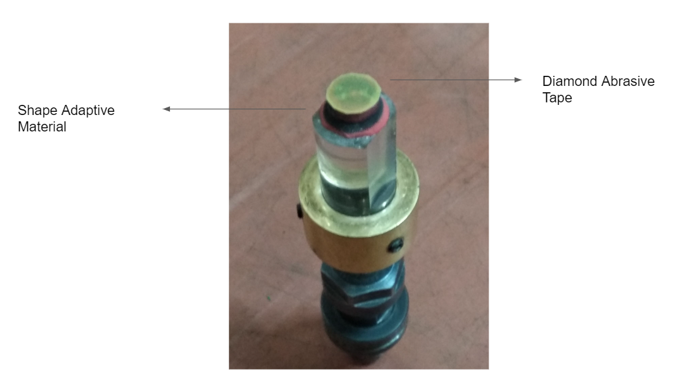

Fig 5. Tool used for shape adaptive grinding

Fig 6 shows a schematic of surface finishing using the rigid and flexible tools. The flexible nature of the tool has allowed the tool to modify its shape.

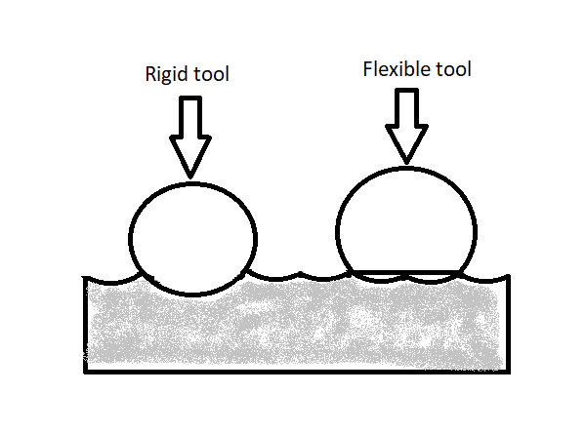

Fig 6. Rigid and flexible tool

The diameter of the workpiece used in the experiment is 40 mm and the diameter of the tool is 15 mm. On one side of the workpiece, we have used a parallel path and on another side, we have used a circular path. On the side where the parallel path is used two different overlapping are used, after the first pass 20% overlapping is used while after 2nd pass 40% overlapping is used. On the other side where a circular path is used overlapping is taken as 20%. On the surface where the parallel path is used have 5 different regions the value of surface finish is taken for those five

regions and for the circular path there are 3 different regions and 3 different value of surface finishing is taken. Fig 7 and 8 shows path planning on both sides of the workpiece along with overlapping regions.

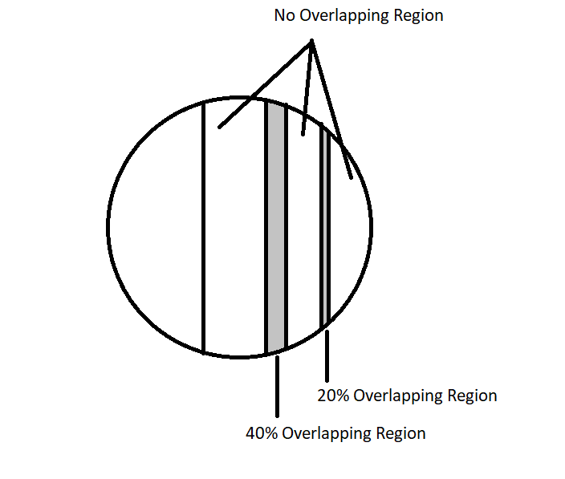

Fig 7. One side of the workpiece with 20 % and 40% overlapping

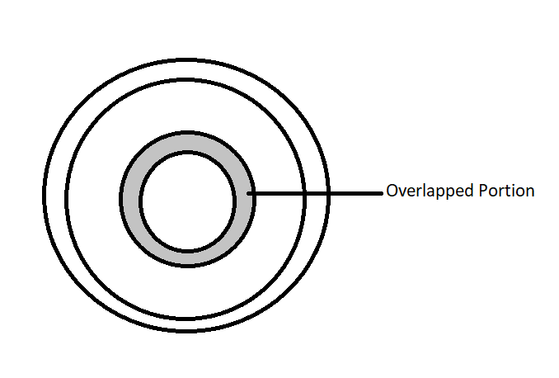

Fig 8. Another side of the specimen with 20% overlapping

The programs used for the experiments:

1. For straight path with overlappings

N100 G21

N102 G0 G17 G40 G49 G80 G90

N106 G0 G90 G54 X25 Y15

N108 G0 Z5

N112 G1 Z-0.1 F50 S1500 M3

N116 G01 X-25

N118 G01 Z5

N119 G00 X25 Y3

N120 G1 Z-0.1 F50 S1500 M3

N122 G01 X-25

N126 G01 Z5

N128 G00 X25 Y-6

N130 G1 Z-0.1 F50 S1500 M3

N132 G01 X-25

N134 G01 Z5

N136 M5

N138 M30

1. For circular path with overlapping

N100 G21

N102 G0 G17 G40 G49 G80 G90

N106 G0 G90 G54 X-7.5 Y0

N108 G0 Z5

N112 G1 Z-0.1 F50 S1500 M3

N116 G02 X7.5 Y0 R7.5 F50

N118 G02 X-7.5 Y0 R7.5 F50

N119 G01 Z5

N120 G01 X-19.5 Y0

N121 G1 Z-0.1 F50 S1500 M3

N122 G02 X19.5 Y0 R19.5 F50

N124 G02 X-19.5 Y0 R19.5 F50

N126 G01 Z5

N128 M5

N130 M30

**Results and Discussion**

On the surface where the parallel path is used region 1 to 5 is from right to left in Fig 7. Table 1 and 2 list the roughness values of different regions.

Table 1. Surface roughness values for the parallel path

|  |  |  |
| --- | --- | --- |
| Surface | Roughness Value(in nm) | Surface profile |
| Raw Surface | 762 |  |
| Surface 1 | 444 |  |
| Surface 2 (20% overlapping ) | 317 |  |
| Surface 3 | 452 |  |
| Surface 4 (40% overlapping) | 434 |  |
| Surface 5 | 517 |  |

In the parallel path, minimum surface roughness of 317 nm is obtained on path with 20% overlapping while the maximum surface roughness is obtained on surface 5. In circular path, minimum surface roughness of 277 nm is obtained on path with 20% overlapping while the maximum surface roughness is obtained on outer surface. The percentage reduction in surface roughness is higher for circular path as compared to parallel path. The possible reason could be the forces acting at the tool-workpiece interface. In circular path, the tool is having curvilinear motion and the force of shearing will be minimum as compared to parallel path.

Table 2. Surface roughness values for the circular path

|  |  |  |
| --- | --- | --- |
| Surface | Roughness Value(in nm) | Surface profile |
| Raw Surface | 762 |  |
| Inner Surface | 340 |  |
| Overlapping Surface | 277 |  |
| Outer Surface | 442 |  |

**Conclusion**

Looking at the result it can be seen easily that the surfaces with overlapping has a better finish than the surfaces with no overlap. Among the surfaces with overlap, the surface with 20% overlap has a higher finish than the 40% overlap. So there is no need of 40% overlapping as it will increase the total time taken for finishing. The best result is from the circular path side surface 2 which is 277 nm. While in no overlapping region the best result is from the circular inner surface 1 which is 340 nm. So it can be said that the circular path is better that the straight path and 20% overlapping is better than 40%.

**References**

[1] Jain, V.K., 2008. Abrasive-based nano-finishing techniques: an overview. Machining Science and Technology, 12(3), pp.257-294.

[2] Prakash, C., Singh, S., Pramanik, A., Basak, A., Królczyk, G., Bogdan-Chudy, M., Wu, Y.L. and Zheng, H.Y., 2021. Experimental investigation into nano-finishing of β-TNTZ alloy using magnetorheological fluid magnetic abrasive finishing process for orthopedic applications. Journal of Materials Research and Technology, 11, pp.600-617.

[3] Barman, A. and Das, M., 2019. Toolpath generation and finishing of bio-titanium alloy using novel polishing tool in MFAF process. *The International Journal of Advanced Manufacturing Technology*, *100*(5), pp.1123-1135.

[4] Rajput, A.S., Singh, A., Kapil, S. and Das, M., 2022. Investigations on the trochoidal toolpath for processing the biomaterial through magnetorheological fluid assisted finishing process. *Journal of Manufacturing Processes*, *76*, pp.812-827.

[5] Ghosh, G., Sidpara, A. and Bandyopadhyay, P.P., 2018. High efficiency chemical assisted nanofinishing of HVOF sprayed WC-Co coating. *Surface and Coatings Technology*, *334*, pp.204-214.

[6] Kumar, M., Sidpara, A.M. and Racherla, V., 2022. Finishing of OFHC copper using fluid filled open-cell porous flexible abrasive impregnated tools. Proceedings of the Institution of Mechanical Engineers, Part B: Journal of Engineering Manufacture, p.09544054221111879.